Suggested Cocktail List

 You simply add the alcohol

Choose from the following delicious flavours:

Delicious Pineapple, Mango, Lemon, Lime, Tropical, Raspberry, Strawberry, Coconut, Watermelon, Cola, or Blue Lemonade and mix with your favourite bottle of spirit such as Vodka, Gin, Rum, etc.

HANDY HINT: KEEP IT SIMPLE BY JUST ADDING YOUR FAVOURITE ALCOHOL TO ANY OF OUR DELICIOUS FLAVOUR BASES

We supply the machine and the 2 Flavour Bases of your choice (from above choices) & you add 700ml of your favourite alcohol such as Vodka, Gin, Rum, Cointreau, Whiskey, etc to any of our supplied base flavours or something different you can add a few different alcohols and try......

The Cocktail For A Song Summer Breeze
Vodka (700ml), Triple Sec or Cointreau (200ml) & Our Blue Lemonade Base.!

The Fruit Tingle
Vodka (750ml),... Our Fruit Tingle Premium Base - Tastes just like a lifesaver!

Sex on the beach
Vodka(700ml) & SEX ON THE BEACH Base... Yeah Baby!

Delicious Lemon or Margarita
Tequil(700ml) a , Triple Sec (150ml) & Our Margarita or Lemon Base ! Toro! Toro! Toro!

The Blue Hawaiian
White Rum (500ml), Blue Curacao (200ml) , Cointreau (200ml), Blue Lemonade Base. Hawaii !

Tempting Tequila Sunrise
Tequila (700ml), Tropical Base. "Da Da Da Dah Da Du Du - Tequila!"

The Pina Colada
Pina Colada Premium Base & White Rum (700ml) .eh Mon!

Tropical Paradise (Rum)
Rum (700ml) & Our Tropical Base - An island favourite!
Rum or Bourbon or Scotch & Cola
White Rum or Bourbon or Your Favourite Scotch (700ml) and Our Cola Base = AMAZING!

The Black Russian
Vodka (700ml) & Mocha Premium Base*.From Russia With Love!

The Splice
Melon Liquor (350ml), White Rum , (350ml) & Our Pineapple Base....Yum!
The Illusion (Midori)
Mix Midori (700ml), Triple Sec or Cointreau (200ml) with Our Lemon Base For the Most Amazing Illusions Ever! (TIP: Add ½ can of Golden Circle Unsweetened Pineapple Juice for an Amazing Result!!!) or just add Vodka to our premium Illusion Base.
The Amazing Lychee Delight
Mix Vodka (700ml), Triple Sec or Cointreau (200ml) with Our Premium LYCHEE Base* For A Refreshingly Different Sophisticated Cocktail!
Mocha Madness
Mix Kahlua (700ml) with Our Mocha Base* For Chocolate/Cofee Cocktail! (Mix with fresh milk for an icy milk delight) (Special Imported delicious coffee mix – extra fee applies)

The Classic Daiquiri
Strawberry (Stawberry Base) and White Rum. (700ml) Oh Behave!or Succulent Mangoes (Mango Base) and White Rum.Do the Mango Tango!
If your favourite drink isn't here, let us know!
Drinks can also be made as non-alcoholic Mocktails or you can enjoy our delicious Bases on their own as amazing non alcoholic Granitas
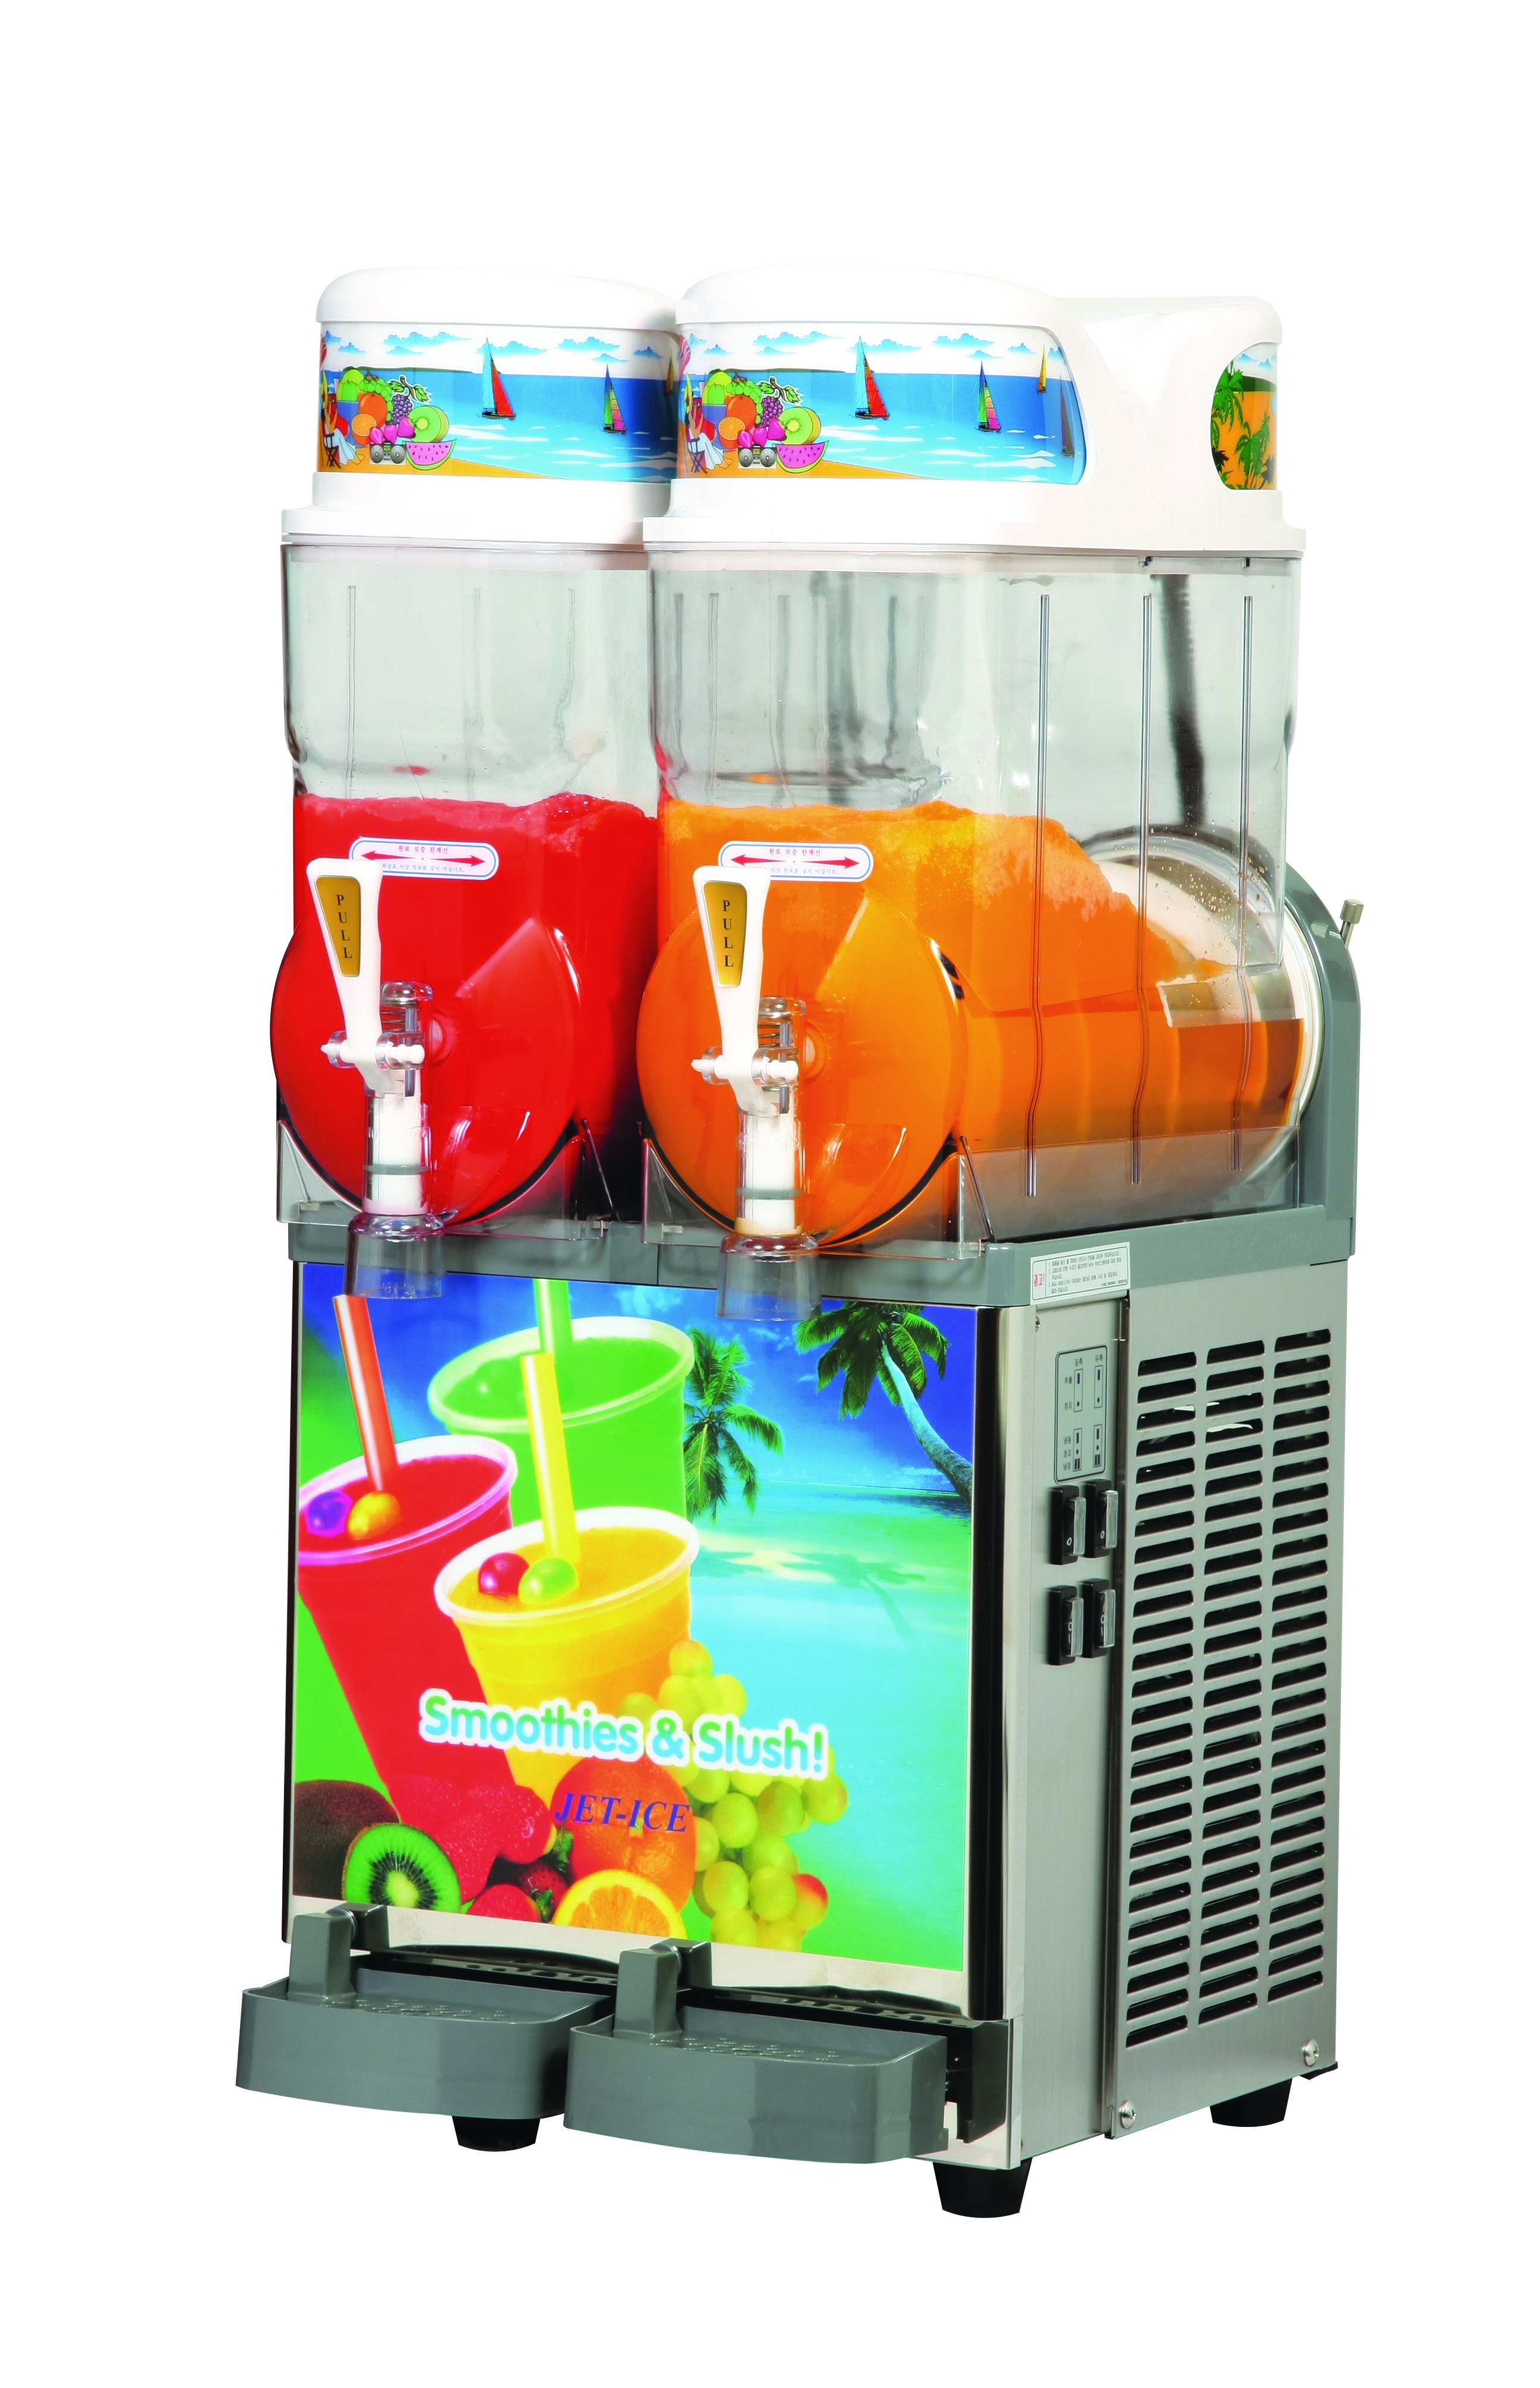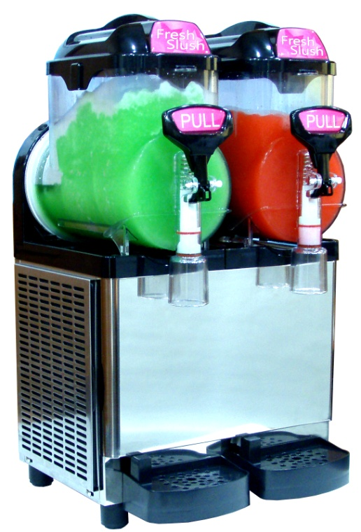


JetIceSlush.com.au

